Subject : DSE(Computer Applications) Cyber Forensics

Practical 3

- Analysis of Windows registry
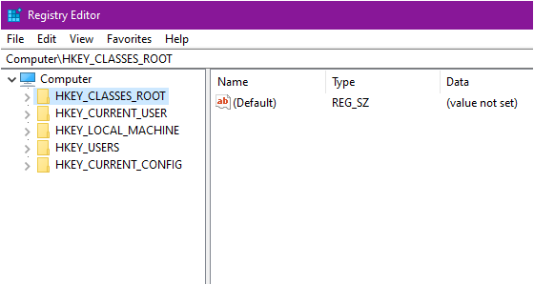
Figure 1. Root Keys Displayed in Windows Registry Editor

- The Windows Registry is a central hierarchical database that stores:
  - System configuration
  - Hardware & driver info
  - Installed applications
  - User activities
  - User-specific settings (MRU, Run commands, USB devices etc.)
- It is extremely important for forensic investigations because it contains user behaviour traces.
- The Figure 1 shows the Windows Registry Editor displaying the five main root keys of the registry.
- These top-level hives—
  - HKEY_CLASSES_ROOT,
  - HKEY_CURRENT_USER,
  - HKEY_LOCAL_MACHINE,
  - HKEY_USERS, and
  - HKEY_CURRENT_CONFIG
- They organize all system, user, and application settings in Windows. They form the starting point for navigating the registry during analysis.
- Tools Used for Registry Forensics :
• Regshot
• Registry Editor (regedit) [Figure 1]
• MUICache View
• Process Monitor
• USBDeview
• RegRipper
- For the practical, Regshot is used to compare registry before and after software installation.
Windows Registry Analysis Using Regshot
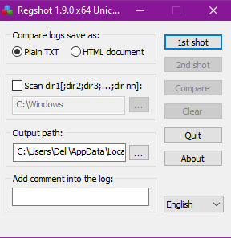

STEP 1 — Take the First Registry Snapshot
Open Regshot and take the first snapshot.

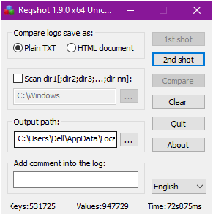

STEP 2 — Install a Software or Perform an Activity
- Now install any software or perform some action (e.g., opening a file, plugging USB, modifying settings).
- This creates changes in Registry keys.

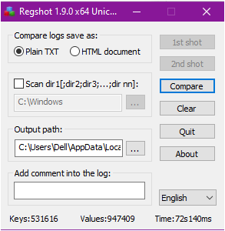


STEP 4 — Compare both Snapshots
Click Compare.

STEP 3 — Take the Second Registry Snapshot
After installation, take the second Regshot snapshot.

STEP 5 — View Registry Changes
Regshot displays :
- New Keys Added
- Values Changed
- Deleted Entries
See the output through this link : ~res-x64_0000.txt

Why Registry Analysis Matters ??

- Registry artifacts help forensic investigators confirm:
  - Applications installed
  - User login activity
  - USB device history
  - Browser history traces
  - Last opened documents
  - Malware persistence keys

- It is a critical part of timeline analysis and intrusion reconstruction.

